## Configuring SharePoint 2010 Service Applications

**Lab Time**: 45 minutes

**Lab Folder**: C:\Student\Labs\10.ManagedMetadata

**Lab Overview**: In the following lab, you will learn how to configure managed metadata.

### Exercise 1: Create a Term Store using the Managed Metadata Manager

In this lab you will begin to work with the Managed Metadata Store.

1. Go to home page of **SharePoint 2010 Central Administration**.
2. Click the **Manage service applications** link in the **Application Management** section to navigate the **Manage Service Applications** page.
3. On the **Manage Service Applications** page, you should notice that several buttons become available in the ribbon.
   1. **Manage**: click this button if you want to create/update the taxonomies in the term store.
   2. **Properties**: this will open a dialog where you can view/change the information you entered when creating the service.
   3. **Administrators**: this button brings you to a page where you can specify the users who have rights to manage this service.
   4. **Permissions**: this button brings you to a page where you can specify the accounts that also have access to invoke the service.
   5. **Publish**: to make the service available to other server farms.
4. Select the **Managed Metadata Service** from the list of service applications and then click the **Manage** button in the ribbon. This will allow you to navigate to the main administrative page for the Managed Metadata Services.

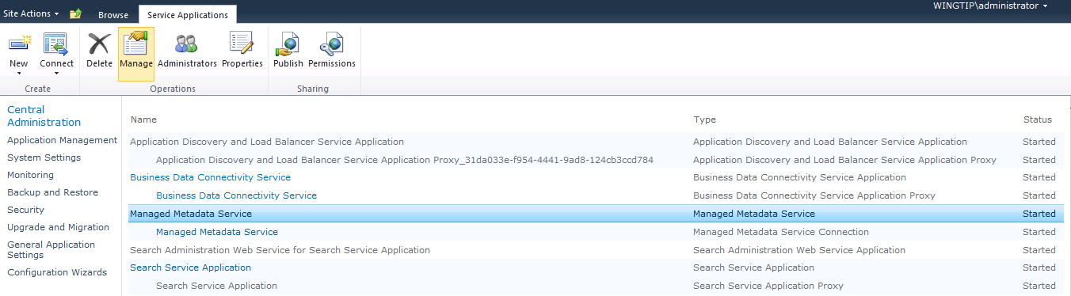

1. You should now be at main administrative page for the Managed Metadata Service called the **Term Store Management Tool**. From within this page you can manage the different term sets that define your company’s taxonomy.

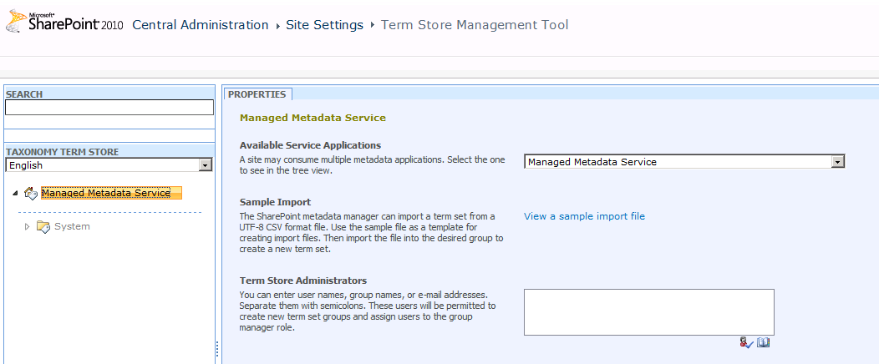

1. You must add one or more users as term store administrator. These users will be able to create new term set groups and assign users to the group manager role. Add the account of WINGTIP\Administrator and WINGTIP\TedP as term store administrator. Click the **Save** button to save your changes.

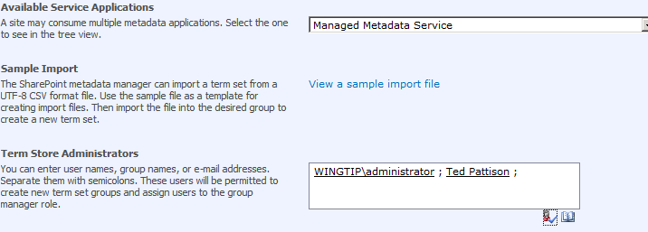

1. If you would have installed language packs, you could select another language as the default language. Or you could keep English as the default language and add the other languages as working languages. This will enable you to specify translations for the terms in the term store.

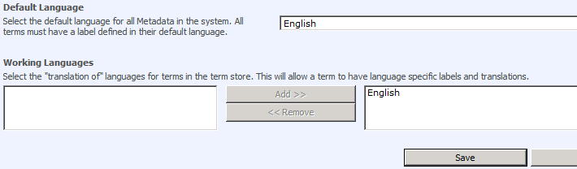

1. You can now start to configure the term store in the left part of the page. Click the arrow next to **Managed Metadata Service** and choose **New Group**. A term group can contain one or more term sets. But a group is more a permission container for which you can configure permissions. Give the new group the name of **Sales**.

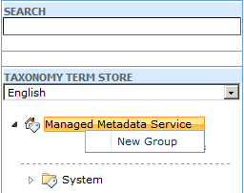

1. On the right of the page you can define the **Group Managers**. These users will be able to manage this particular group. Add the account of **Andrew Connell** as **Group Manager**.
2. You can also assign contributors to this group. A **contributor** is a user that can add term sets and terms within this group. Add **Scot Hillier** as a contributor.

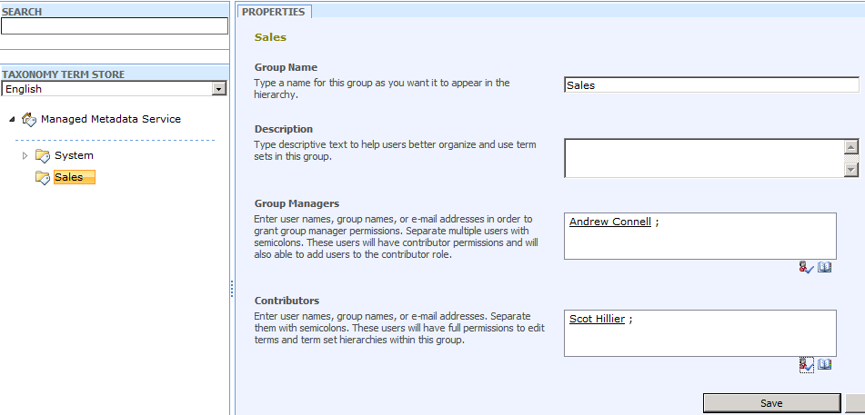

1. Click the **Save** button to not lose your changes.
2. A term group can contain one or more term sets. A **term set** defines a taxonomy containing a hierarchy of terms. Click the arrow next to the **Sales** group and choose **New Term Set**. Name the term set **Territories**.

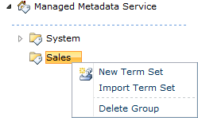

1. Also at this level you can manage a number of properties:
2. **Term set** **name**
   1. **Description**
   2. **Owner**
   3. **Contact**: if you want to allow users to send suggestions to ameliorate the quality of your taxonomy, you can specify an email address. If you leave this field blank, users will not be able to send suggestions. Enter the mail address tedp@wingtip.com.
   4. **Stakeholders**: if certain people within the company need to be notified when major changes are made to the term set, you can specify the accounts of these users or groups.
   5. **Submission Policy**: here you decide whether users can add terms to the term set or not. If the taxonomy is closed, users will not be able to add terms.
   6. **Available for tagging**: if this property is checked users will be able to use the term set when tagging their list items within the SharePoint sites. If this property is unchecked, the term set will only be available through columns of type Managed Metadata.

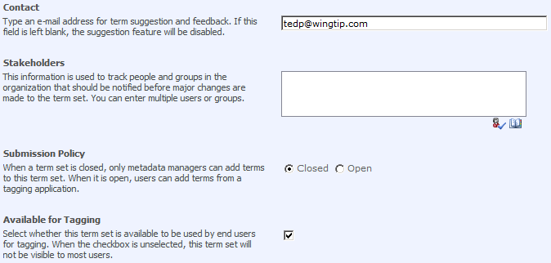

1. Click the **Save** button to not lose your changes.
2. Add the term **United States** to the **Territories** term set. Also at this level you can set a number of properties to further configure the taxonomy.
3. **Available for tagging**: if you configured that your term set is available for tagging, you can specify at this level whether this specific term is available for tagging or not. Unchecking the option does not make the child terms unavailable for tagging.
   1. **Language**
   2. **Description**
   3. **Default label**
   4. **Other labels**: you can specify synonyms for each term.

Don’t forget to save your changes before going back to the term store treeview

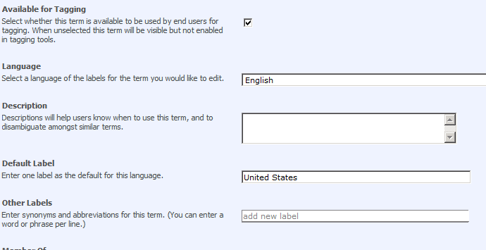

1. Add a hierarchy of terms to the term set as shown in the picture. Also, create a second term set **Document Types** within the **Sales** group. Set its **Submission Policy** to **Open** to allow users to add terms to the term set.

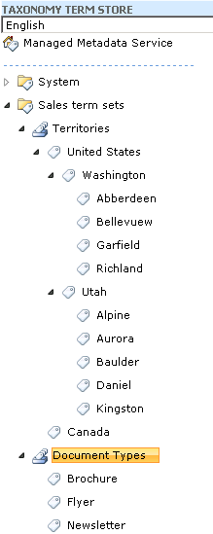

1. Specify synonyms for

**Utah:** UT

**Washington:** WA

Don’t forget to save each change. If you receive a message stating the Term Store is unavailable, navigate to the home page of Central Administration and the back to Term Store Management Tool.

### Exercise 2: Tag Content

In this exercise you will learn how users can work with the taxonomies you defined in the SharePoint Central Administration.

1. Open the SharePoint site at navigate to the site at http://intranet.wingtip.com.
2. Navigate to the **Site Collections Documents** library and choose the **Library Settings** button located in the **Library** tab.

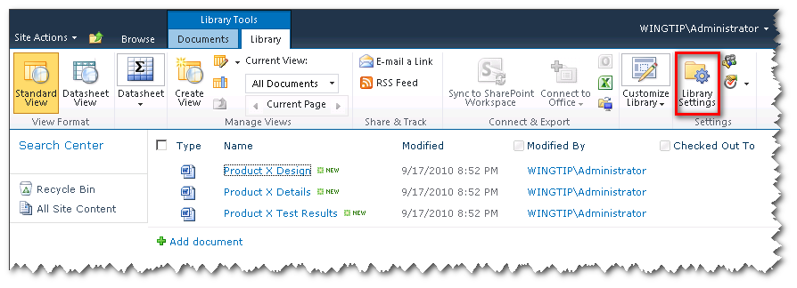

1. Select the **Enterprise Metadata and Keywords Settings** hyperlink under the **Permissions and Management** section.

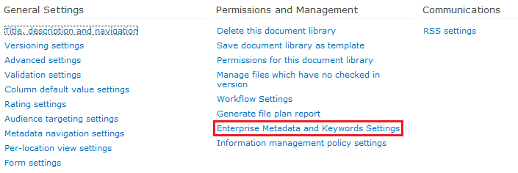

1. Select both check boxes and choose **Save**.
2. Go back to the list view of the library and edit the properties of one of the documents.
3. Notice the new field **Enterprise Keywords**. Enter the letter W and look at the tags suggested. You can select one of the suggestions, or fill out a completely other word like **Waterloo**.

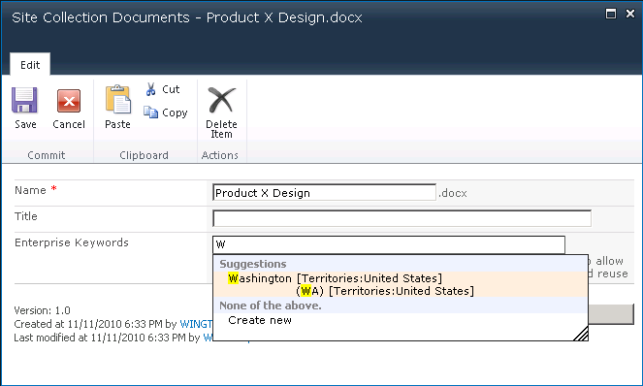

1. **Save** the item.
2. You can also create columns based on managed metadata. Go back to the **Document Library Settings** page and choose **Create column**.
3. Give it the name **Territory** and choose **Managed Metadata** as data type.
4. Scroll down to the **Term Set Settings** section. Expand the **Managed Metadata Service** treeview and select **Territories** term set from the **Sales** term setsgroup.

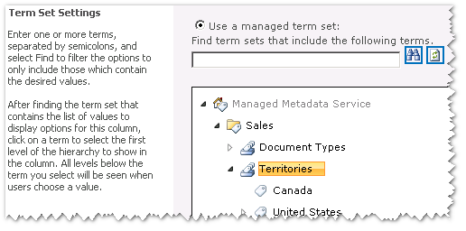

1. Click the **OK** button.
2. Add a second column of the **Managed Metadata** data type. Give it the name **Document Type** and choose the **Document Types** term set from the **Sales** term sets group.
3. As you defined this as an open term set, users are allowed to add new terms to the term set while editing there list items. At this stage you can still decide whether the users are allowed to add terms or not. Select **Yes** for **Allow ‘Fill-in’ choices**.



1. Click the **OK** button.
2. Go back to the list view of the library and edit the properties of one of the documents.
3. Notice the two new fields. Click the **Tag** icon next to the **Territory** field.

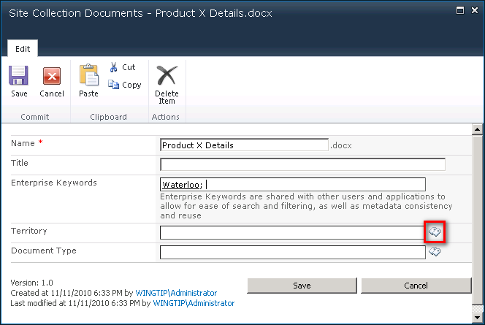

1. In the **Managed Metadata** picker choose a city from the **Washington** territory. Alternatively, you could also start to fill out the name of the desired territory. A list of suggestions will be displayed under the text box.
2. Notice also the **Send feedback** hyperlink in the upper part of the dialog. This can be used to send suggestions to the user defined as contact for this group. Click the **OK** button.
3. Click the **Tag** icon next to the **Document Type** field.
4. Click the **Add New Item** hyperlink in the upper part of the dialog to add a new term. Enter **Slide Deck** as new term.

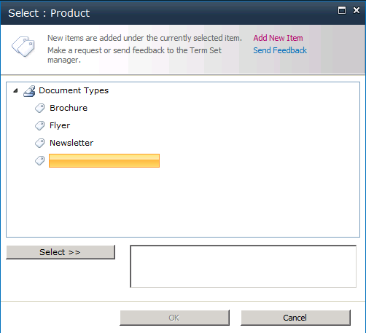

1. Click away from the new tag. Notice how the newly created tag appears in the selected text box. Click the **OK** button and **Save**.
2. Go back to the term store in the **SharePoint 2010 Central Administration** and expand the **Document Types** term set in the **Sales term sets** group. Notice that the **Slide Deck** term is added to the term set.

### Exercise 4: Add Metadata Navigation to the Document Library

Navigating through document libraries full of folders and documents could be time consuming in SharePoint 2007. In this exercise you will learn how you can add navigation support to the document library based on managed metadata.

1. Open the SharePoint site at http://intranet.wingtip.com.
2. Navigate to the **Site Collections Documents** library and choose the **Library Settings** button.

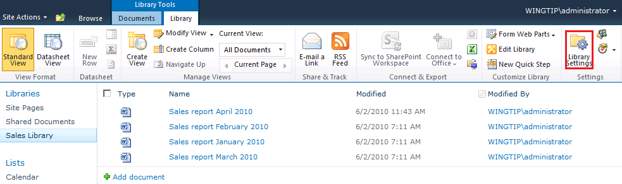

1. Select the **Metadata navigation settings** hyperlink under the **General Settings** section.

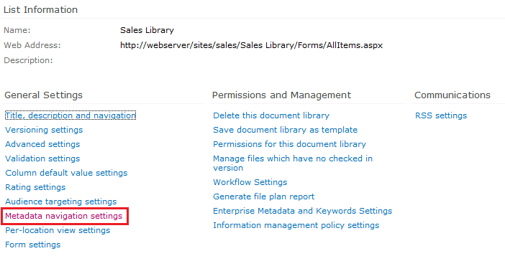

1. The first section allows you to show managed metadata as a treeview right under the site hierarchy treeview. The document library contains metadata columns for **Document Type** and **Territory** information.
2. Add both columns to the second list box.

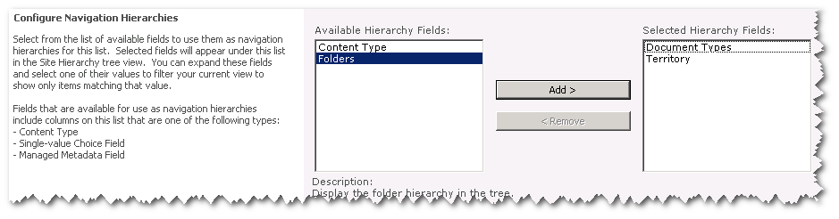

1. Click the **OK** button and return to the document library.
2. Notice the treeview containing the taxonomies. Select for example the **slide deck** term in the **Document Types** term set. This will filter the document library.

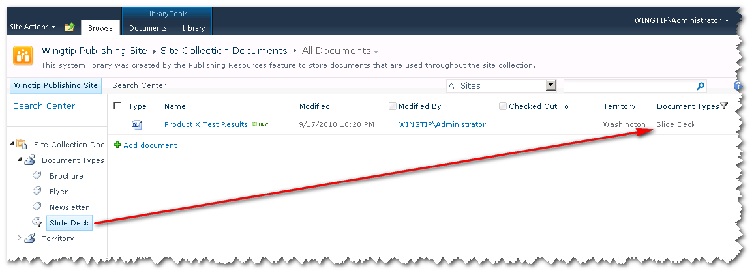

1. You can also add filters. Return to the **Library Settings** page and select the **Metadata navigation settings** hyperlink again.
2. The second section allows you to define for which metadata columns you want to add Filter text boxes. Add the columns **Document Types**, **Territory** and **All Tags** to the second list box.

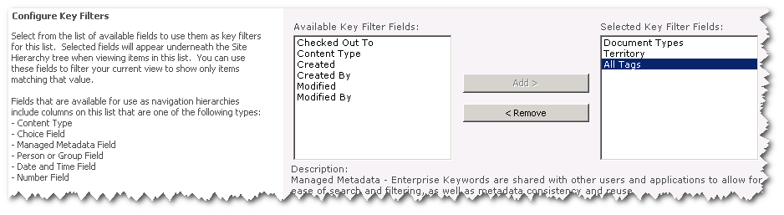

1. Click the **OK** button and return to the document library. Notice that **Key Filters** have been added.

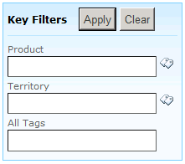

1. Also here you can use the metadata picker or type in a value. Enter for example **Baulder** in the **Territory** text box and click the **Apply** button.

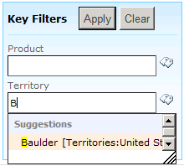

1. Notice that the document library gets filtered.

### Exercise 5: Manage the Term Sets from within a Site Collection

In this exercise you will learn how you can access and manage the term store from within a site collection.

1. Return to the home page of the http://intranet.wingtip.com site.
2. Go to the **Site Settings** page of this site via the **Site Actions** menu.
3. Select the **Term store management** hyperlink under the **Site Administration** section.
4. You can manage the complete term store from here. Add a new state to the **Territories** term set.
5. Go back to the term store in the **SharePoint Central Administration** and expand the **Territories** group. Notice that this group can be managed from within the SharePoint Central Administration.